Nutley Raiders Summer Tennis Camp 2021
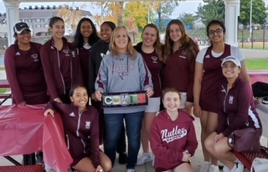
Dates: Monday, July 19TH to Thursday, July 22Th (Rain Date: Friday 23rd)
Time: 9:30am to 11:30 am
Location: Demuro Park Courts, Wilson Ave. Nutley
School Grade Level: Grades 4th – 8th
Daily Schedule:  9:30 – Drop off  9:35 to 9:45 – Stretching/Warm-up  9:45 to 10:30 – Daily Skill, demo, practice  10:30 to 10:40 – Snack break / cool down  10:40 to 11:20 – Drills, Games for Daily Skill  11:20 to 11:30 - Daily review Q&A  11:30 – End of Session / Parent pick up  Daily Skills include:  Forehand, Backhand, Volley, Overhead, Lob, and Serve  Camp Sign Up Fee:  $125 |  | Camp Highlights:  - All skill levels encouraged to participate, the camp will cater to all skill levels  - Opportunity to work with Head Tennis Coach Valerie Martin/Assistant Coach Joe Martin and Varsity Athletes  - All participants will receive a camp T-Shirt  - Tennis games and contests throughout the camp with tennis gear prizes and giveaways  Required Equipment for Participants:  - Tennis Racket  - Tennis Sneakers  - Small towel or wrist /sweat bands  - Water Bottle
Detach here for sign up form:
Sign Up Form / Participant Information
Name:
Address:
Phone #: |  | Email:
Grade: | Age: | T-Shirt Size:
Parent/Guardian Name:
Parent/Guardian Signature:
Please email, text, or mail the sign up info and payment to Coach Martin on or before July 9th, to:
Coach Valerie Martin - 2 Fairfax Court, Nutley, NJ 07110 - Make checks payable to: Valerie Martin
Contact Coach Martin with any questions – Phone: 973-220-6186, Email: valmar4@optonline.net

